**Statement of Originality**

**Submitted to the**

**Jurnal transformatika**

Title of the manuscript : **(please complete)**

Authors : **(please complete)**

With this paper the authors state the originality of the paper:

1. As the authors we certify that this manuscript is original and its publication does not infringe any copyright.
2. As the authors we declare that the manuscript has not been previously published, in whole or in part in any other journal or scientific publishing company. Also the manuscript does not participate in any other publishing process.
3. As the authors we declare that all persons listed hereafter were committed in the creation of the paper and were informed about their participation.
4. We include the results of the plagiarism check with turnitin or other

( please state ..... ) in the form of a capture image.

So this statement of originality is made without any coercion, thank you

Date, Name and signature of the authors

With meterai Rp. 10.000,- (just one)

(…………………………) (…………………………) (…………………………)

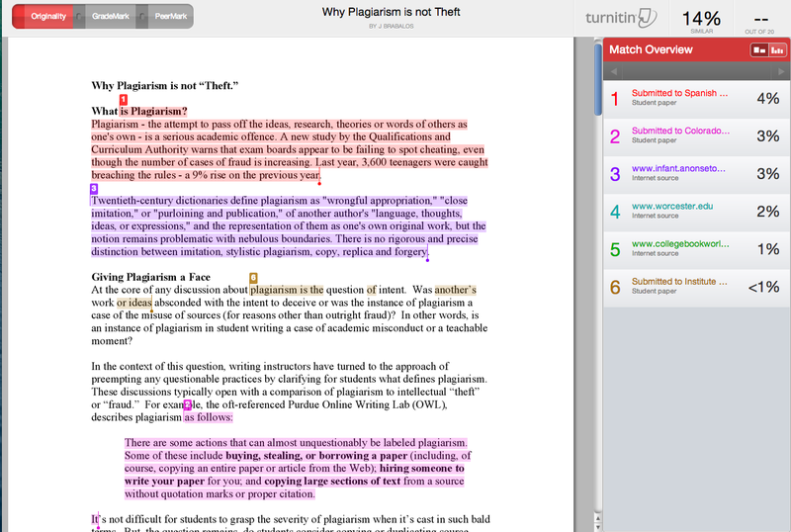

( Contoh cek plagiarisme)